|  |
| --- |
| Walchand College of Engineering, Sangli  (An Autonomous Institute)    Electronics Engineering Students’ Association |
| **Report on**          **ELECTROVERT 2016**        …  Performance Creed          **State Level Technical Symposium**        **17**  **th**    **and 18**  **th**    **S**  **eptember**  **2016** |

# Promotion of event

As a state level competition ELECTROVERT event was promoted all over the Maharashtra though campaigning and newspaper as a result we got a huge response from the students. Also we promoted our event though www.elesa.in website and captive portal of our college Wi-Fi network.

1. Posters and Banners Display
2. Website
3. Captive Portal
4. Social Networking Sites (Facebook, Twitter, WhatsApp)

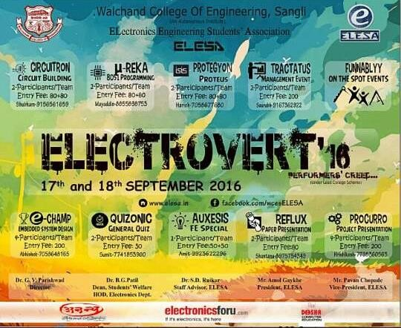

# Participation

There were total **16 colleges** across ‘Shivaji University’ in which our organizing committee members did campaigning of event and itself in a ‘Walchand College of Engineering, Sangli’.

There were total **350** teams participated in **ELECTROVERT 2K16**. More than **800** students had participated in the event. More than **500** students (across Shivaji University, except Walchand College of Engineering) had participated in ELECTROVERT 2k16.

Entries from the following colleges:

|  |  |
| --- | --- |
| **Sr. No.** | **Name Of the College** |
| 1 | Government College of Engineering, Karad |
| 2 | R.I.T. College, Islampur |
| 3 | K.I.T. College, Kolhapur |
| 4 | Government Polytechnic, Kolhapur |
| 5 | Bharati Vidyapeeth College of Engineering, Kolhapur |
| 6 | D.K.T.E.Society`s Engineering Institute College,Ichalkaranji |
| 7 | S.I.T., Ichalkaranji |
| 8 | P.V.P.I.T., Budhgaon |
| 9 | Government Polytechnic, Miraj |
| 10 | Sanjay Ghodawat College of Engineering, Kolhapur |
| 11 | J. J. M. College of Engineering, Jaysingpur |
| 12 | Department of Technology, Kolhapur |
| 13 | Annasaheb Dange College of Engineering & Technology , Ashta |
| 14 | Government Residential Woman Polytechnic, Tasgaon |
| 15 | Vishveshwarya Technical Campus, Miraj |
| 16 | Dr. D. Y. Patil COE, Kolhapur |
| 17 | Adarsh College of Engineering, Ashta |
| 18 | M. D. Jadhav College of Engineering, Bhose |
| 19 | Daulatrao Aher College of Engineering, Karad |
| 20 | Yashwantrao Chavan Polytechnic, Ichalkaranji |
| 21 | Latthe Ploytechnic, Sangli |
| 22 | Walchand College of Engineering, Sangli |
| 23 | Tatyasaheb Kore Institute, Warnanagar |

# Inauguration

**ELESA** - *Electronics Engineering Students’ Association* is a well-known technical association of Walchand College of Engineering, Sangli which molds the amateur engineer through teaching, activities and transform them to be professional in their career. It has successfully produced fruitful results since long by contributing for the technical as well as personality development of the students. Support of the department and college to our association is an appreciative work.

ELECTROVERT had inauguration on **17th September**, 2016 in Girl’s Study Hall at **9:30am**. Our Dignitaries **Dr. G. V. Parishwad,** Director of WCE, **Dr. B. G. Patil**, HOD of Electronics Department and Dean Students’ Welfare, **Dr. S. D. Ruikar**, Staff Advisor of ELESA, **Prof. S. K. Parchandekar** and **Prof. J. S. Shete** were present on the day. All the honorable dignitaries and President Mr. Amol Gaykhe light up lamps. It then followed by the inspiring words of Dr. B. G. Patil and Mr. Amol Gaykhe. All board members of associations and participated students were present for the inaugural ceremony.

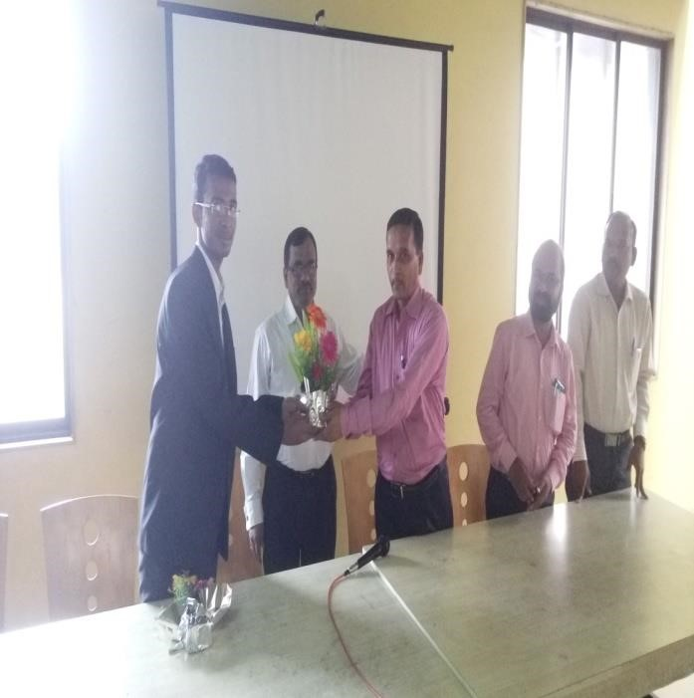

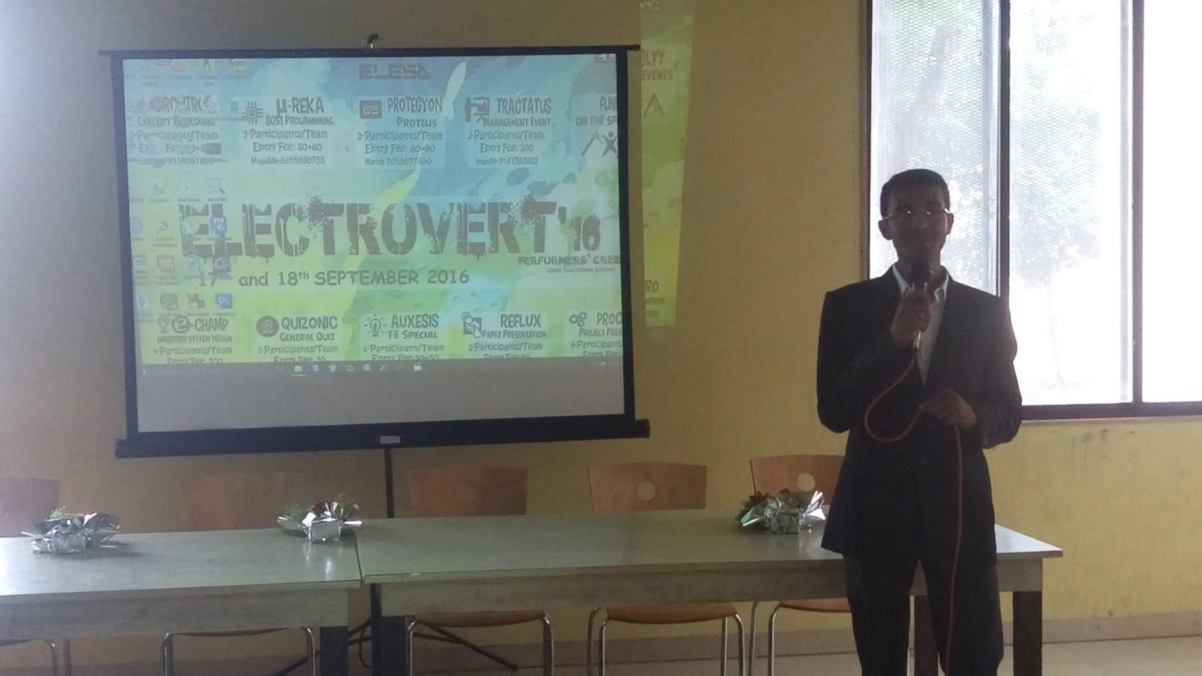

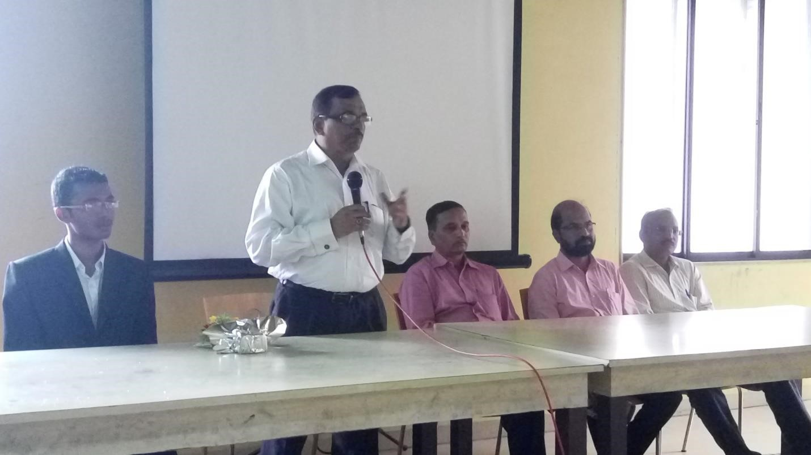

# EVENT STRUCTURE

Being a two day event, there were 10 different sub events

among them 5 on either day. To facilitate good co-ordination and efficient management, competitions were categorized into following committees:

**Circuitron** (Circuit Building Competition)

**Protegyon** (Proteus Software Simulation Competition) **μ-Reka** (8051 Microcontroller Programming Competition)

**Reflux**  (Paper Presentation Competition)

**Procurro** (Project Presentation Competition)

**Auxesis** (Special Event for First Year Student)

**Tractatus** (Business Event)

**Funnably** (On the spot Events)

**Quizonic** (General knowledge and quiz Events) **e-Champ** (Embedded System Design Event)

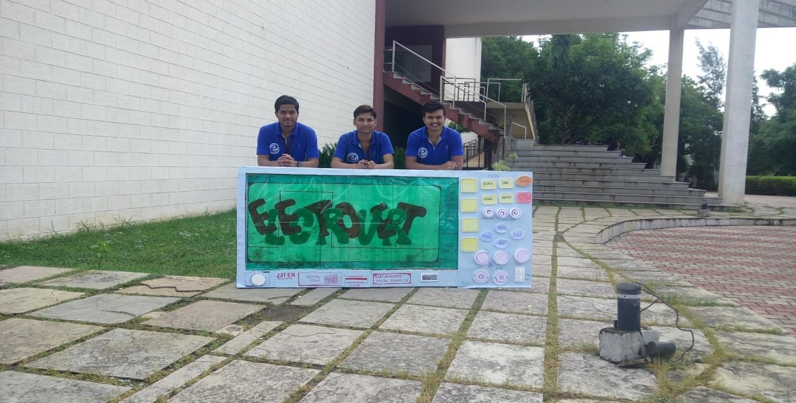

# PROTEGYON

…Drive Your Ideas

We had one sub event PROTEGYON based on PROTEUS software simulation. It was held on 17th September, 2016 from 12.00 pm to 5.00 pm. There were total **34** teams had participated in this event having 2 members in each team. Through this event we checked the ability of the participants to deploy the various facilities available in Proteus simulator for the advanced learning and understanding of the concepts in electronics.

At the end an event was successful which enhanced the skills of all participants as well as volunteers.

Details of our event are as follow:

**Round 1 -** Aptitude Test on 17 Sep. (11:00am to 12:00pm)

It was totally based on the following points having only half hour time limit.

* Basic electronics
* Digital circuits
* Proteus software

**Round 2 -** Debugging round, Design and Simulation (2:30pm to 3:30pm)

This round was designed in such a way that participants had to find the maximum errors from the provided design within stipulated time.

It included four statements totally based on circuit building, circuit debugging, logic development and circuit designing within an hour.

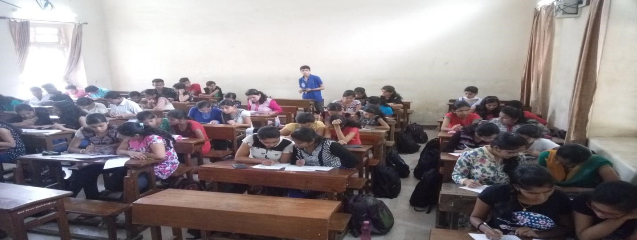

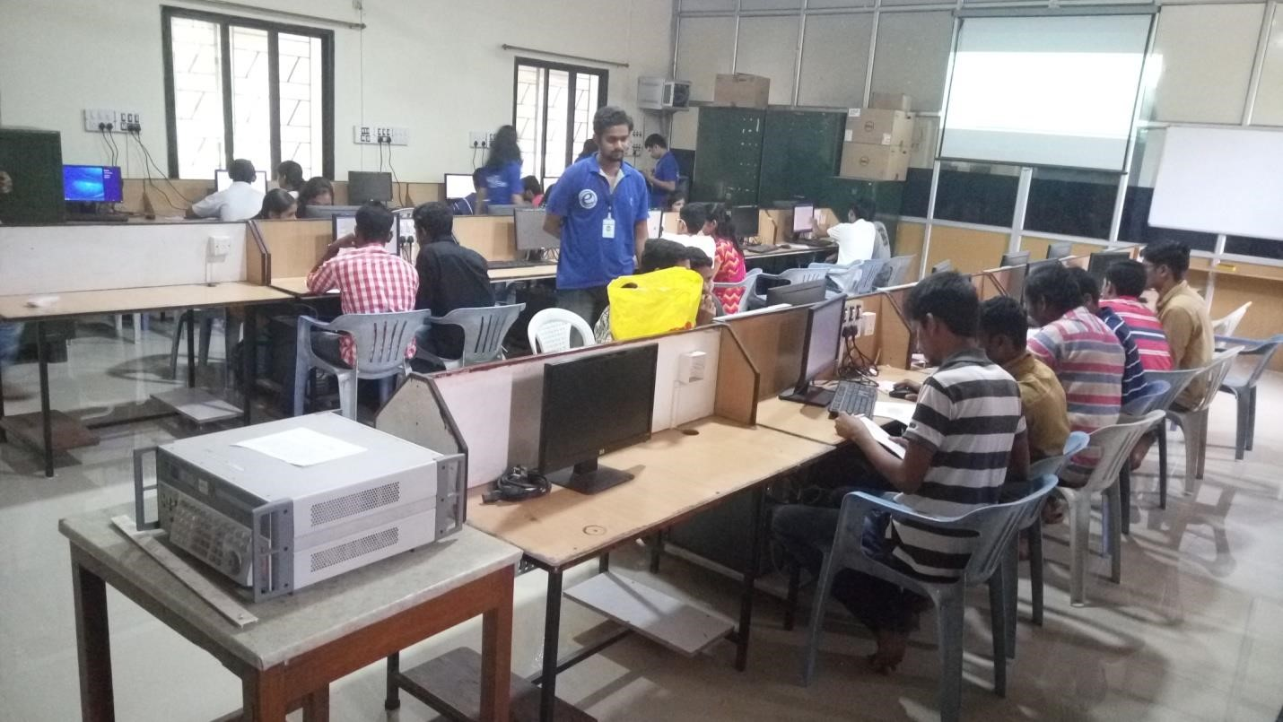

**Venue:** EDA Lab of Electronics Department

**Winner:** Swapnil Mane and Pravin Patil

**Runner up:** Hrushikesh Budhale and Satyajeet Patil

**Organizing Committee:**

|  |  |
| --- | --- |
| **Board** | **Name** |
| B Tech | 1. Samruddhi Kulkarni |
| TY Board | 1. Harish Agrawal 2. Akash Munde 3. Pratik Thepale |
| SY Board | 1. Tejashree Ghogale 2. Sachin Jadhav 3. Harshad Ugale |

# μ-Reka

μ-sions…leap ahead

It was one day programming contest and was conducted on the first day i.e. on 17th September. It was based on 8051 microcontroller programming contest. Total number of entries received for 8051 were **60.** Detail information about this event is as follow: **For 8051 Microcontroller:**

**Round 1-** Aptitude Test on 17th September (10:30am to 11:00am)

It was objective test based on 8051 microcontroller having half hour time limit It was totally based on the following points.

* Architecture
* Assembly
* Rapid Programming

**Round 2-** Simple and Rapid Programming (1:30pm to 2:15pm)

There were only 2 Questions and the time duration of 45 minutes. Total 24 teams were shortlisted for this round. They were given one assembly and one C programming question.

**Round 3-**Problem Statement Solving (4:30pm to 5:30pm)

Final round was based on the complex programing statement having 1 hour time limit and Prof. S. R. Khedkar did judging for this round.

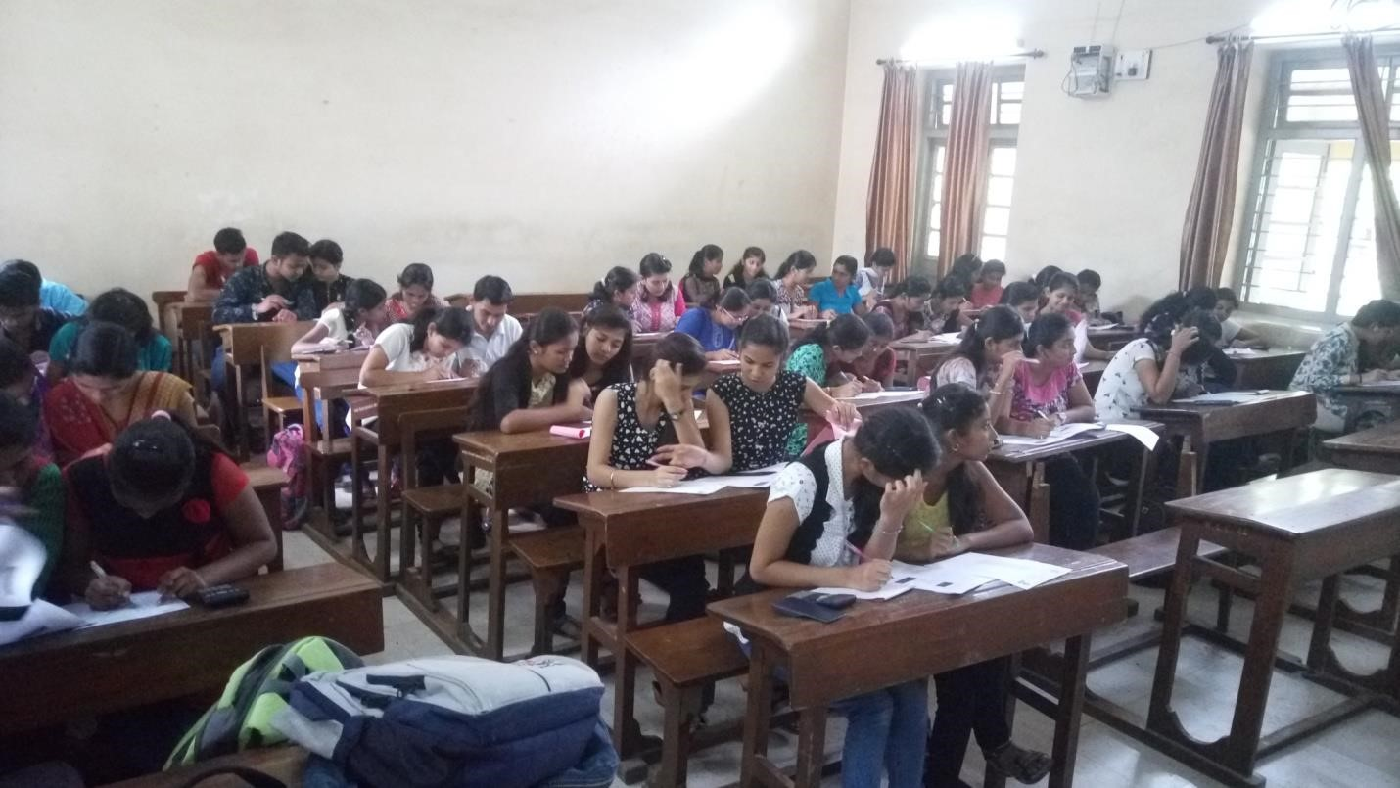

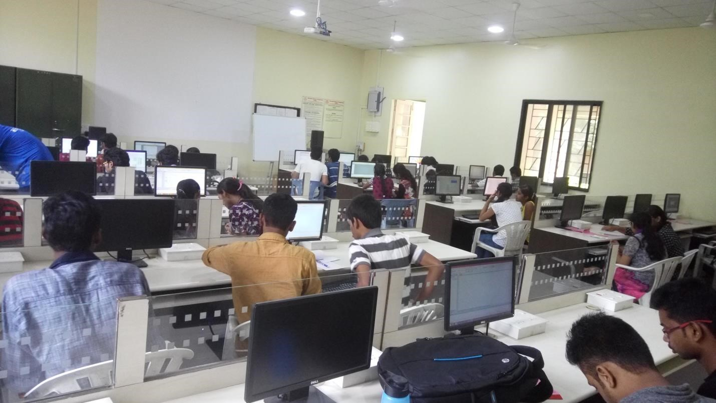

**Judge:** Prof. S. R. Khedkar

**Venue:** ESM Lab of Electronics Department

**Winner:**  Swapnil Mane and Pravin Patil

**Runner up:** Akash Wali and Shradhha Kerpale

**Organizing Committee:**

|  |  |
| --- | --- |
| **Board** | **Name** |
| B Tech | 1. Narsing Mundhe 2. Sarswati Solage |
| TY Board | 1. MayoddinNathani 2. Abhishek Parab 3. Priyanka Desai 4. Hrishikesh Nikam |

# CircuiTron

…Exploit your logic

It was circuit building contest held on 17th September. It comprises of 3 rounds. This event was further categorized as a novice and expert group. Total number of entries was **148**.

**Round 1:** ‘KNACK’ **(**10:00am to 10:30am**)**

It was aptitude test of 30 questions having half hour time limit.

Topics for test:

## NOVICE (FE, SE& ALL DIPLOMATES) EXPERT (TE, BE )

1.Basic Electronics 1.Linear integrated circuits (op-amp)

2.Basic Electrical 2.Analog Communication

3.Circuit Network 3.Signals and System

4.Digital electronics 4.Digital Signal Processing

5.Instrumentation

**Round 2:**’SORPRESA’ (2:30pm to 3:00pm)

There were total 6 subjective questions having 30 minute time limit. Total 33 teams were shortlisted for this round.

**Round 3:**’KING OF CIRCUITO’ (4:30pm to 5:30pm)

It was a final round consist of Circuit Building for a given problem statement.

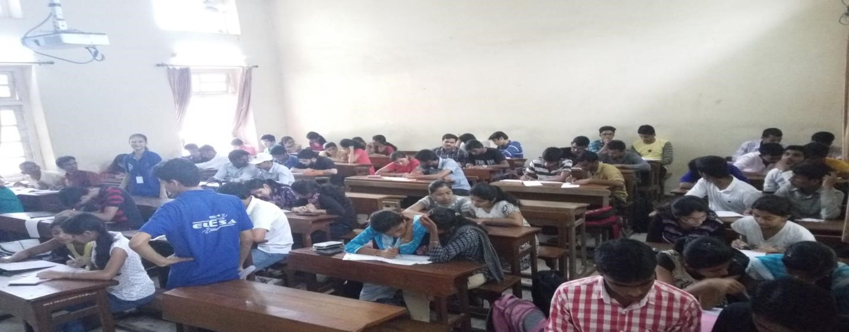

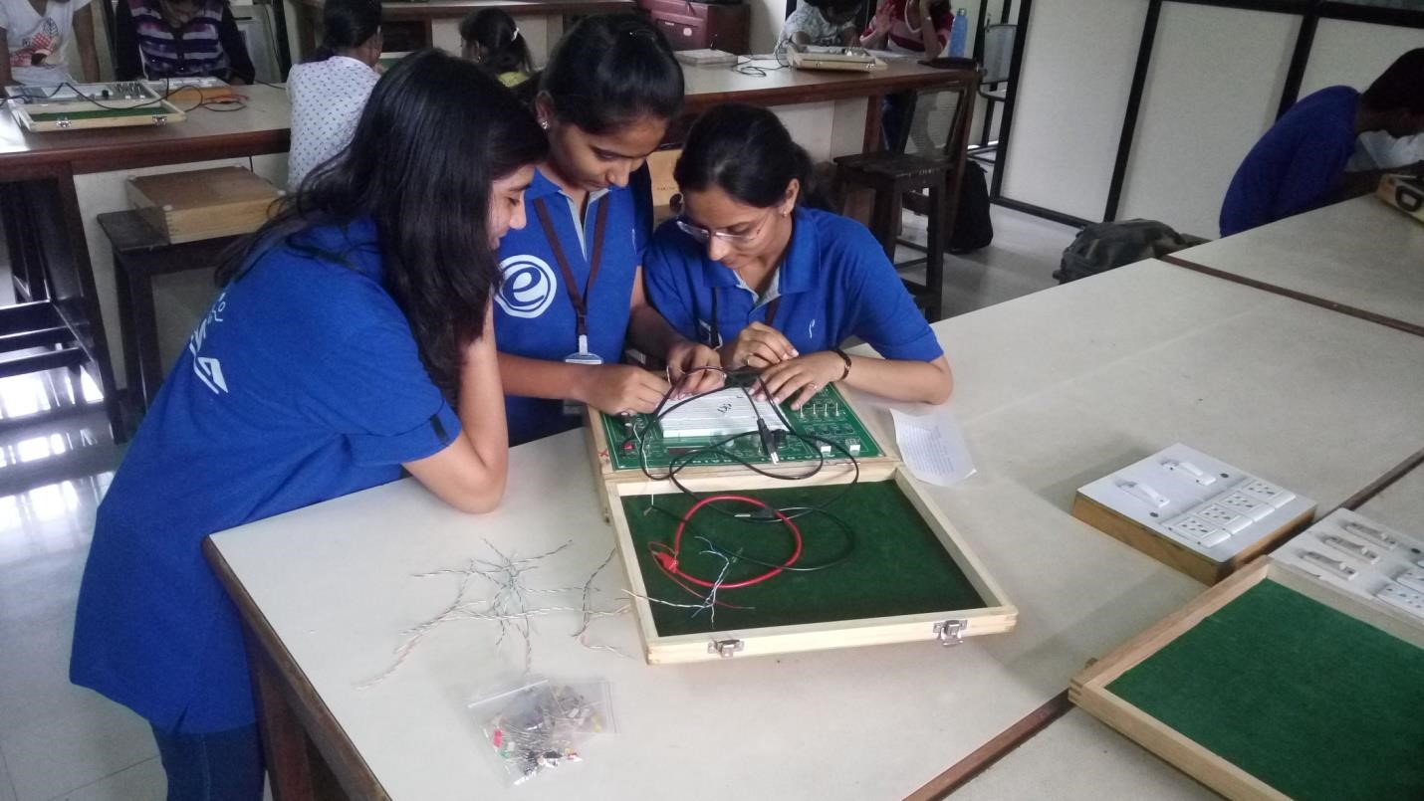

**Judge:** Prof. S. K. Parchandekar

**Venue:** Instrumentation lab & Communication lab of Electronics Department

**Winner (Novice):** Mr. Vijay Gole and Mr. Vikas Ghubade

**Runner up (Novice):** Ms. Sneha Kondekar and Ms. Rutuja Mathkari

**Winner (Expert):** Mr. Aditya Deodhar **Runner up (Expert):** Ms. Supriya Bargole and Ms. Gouri Zore **Organizing Committee:**

|  |  |
| --- | --- |
| **Board** | **Name** |
| B Tech | Tejshree Chaugule |
| TY Board | 1. Shubham Mhatre 2. Omkar Shingare 3. Sunita Patil |
| SY Board | 1. Komal Chandak 2. Shirish Patil 3. Sharvari Kshirsagar 4. Vrushali Shelar |

# TRACTATUS

...Beat the Bid

As of every year, ELECTROVERT has successfully organised a non-

technical event. Similarly this year “**Tractatus**” is our Management event. Briefly, the event will consist of 3 rounds and none of the round will be a pre-event round.

Before the description of rounds, we are going to acquire stocks of some public companies (Apple Inc. Microsoft, Google etc.). These stock values are going to be of a 52 week base (1 year). Our team will create a graphical representation of these values. Along with this, the recent trends in the companies and other monetary changes will be given to the participants just before the start of the event. In addition to this, a brochure containing the specifications and prices of electronic spare parts will also be provided. Participants have to select any one company by means of chits.

**Participating teams need to have one laptop each.**

**ROUND 1**-INVESTMENT

After carefully studying the data given in the documents, the 1st round commences. Firstly teams were given INR 1000000. This round was an investment round.

**ROUND 2**-BIDDING

This round was of l see bidding of the electronic spare parts, which when combined in a particular set, form a product.

**ROUND 3**-CRISIS ABSOLUTION

The companies were deprived of some percentage of their remaining amount. Due to this they were in a state of debt. It was up to the company to strategize a plan out of debt. For that they could sell their spare parts. If they wish, they could break their bonds/policies, sell their stocks etc.

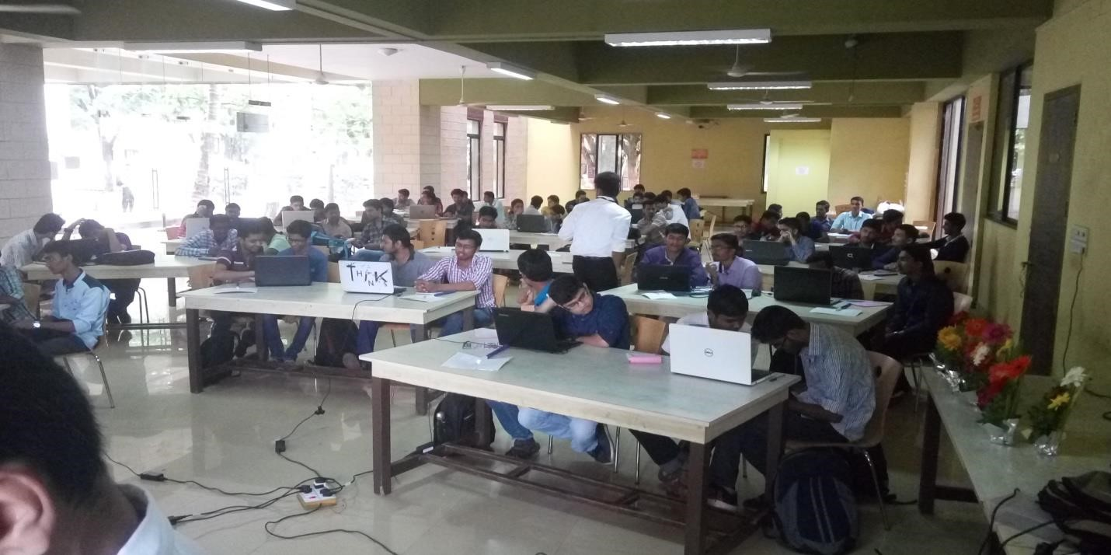

**Venue:** Girl’s Study Hall of College

**Winner:**  Kedar Deshpande and Sadanand Nagargoje **Organizing Committee:**

|  |  |
| --- | --- |
| **Board** | **Name** |
| B Tech | Pawan Chopade |
| TY Board | 1. Saurabh Kale 2. Shantanu Vipradas 3. Swaroop Tingare 4. Amit Patil |
| SY Board | 1. Atul Zine 2. Sumit Shinde 3. Ritu Patil |

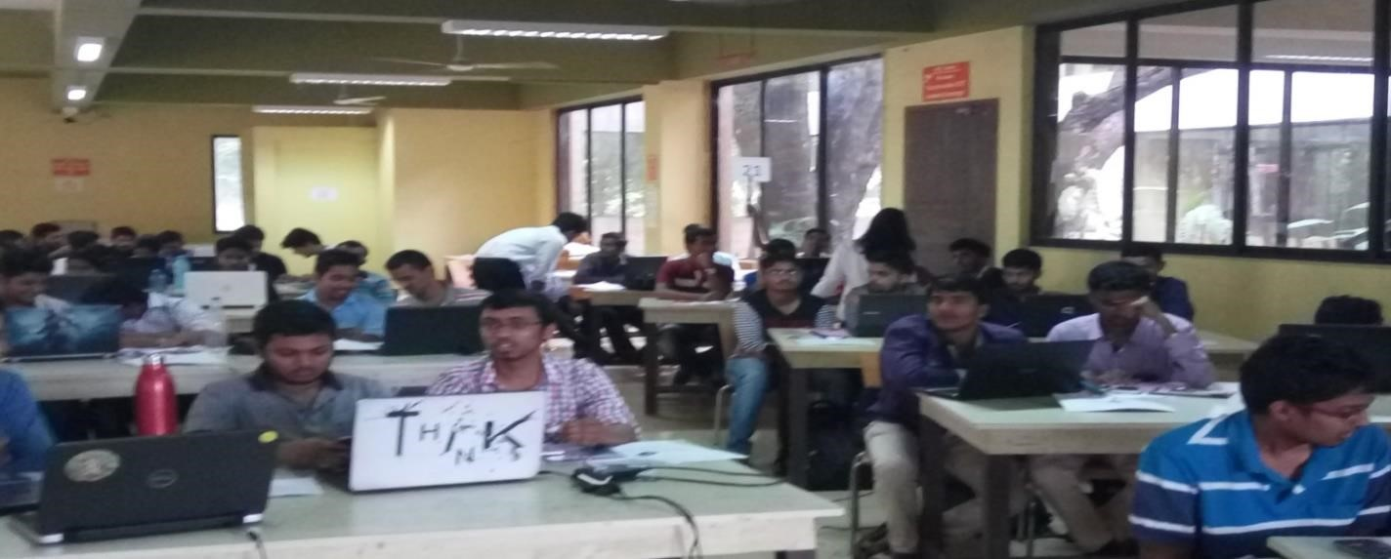

# E- CHAMP

* Full Day Event
* Participants per Team : 4 • Free entries :
  + One Winner team from Proteus Event
  + Two Winner teams from Circuit building event ( each from novice and expert )
  + One Winner team from 8051 event • Entries :
  + Max. limit up to 10 including above 2 teams o If entries exceeded than 10 : Aptitude test for screening

## Event Rounds

• Full Day Event • 3 Phases :

1. Pre-event phase: Provision of study resources, interfacing modules info, datasheets etc.
2. Event- Day (Round 1): Providing problem statement, hardware requirements and questioning by judges during the round.
3. Presentation Phase: Project Demo before all the teams and judges.

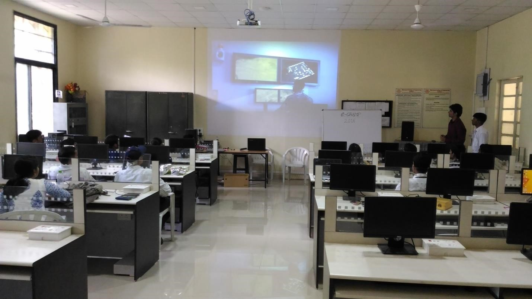

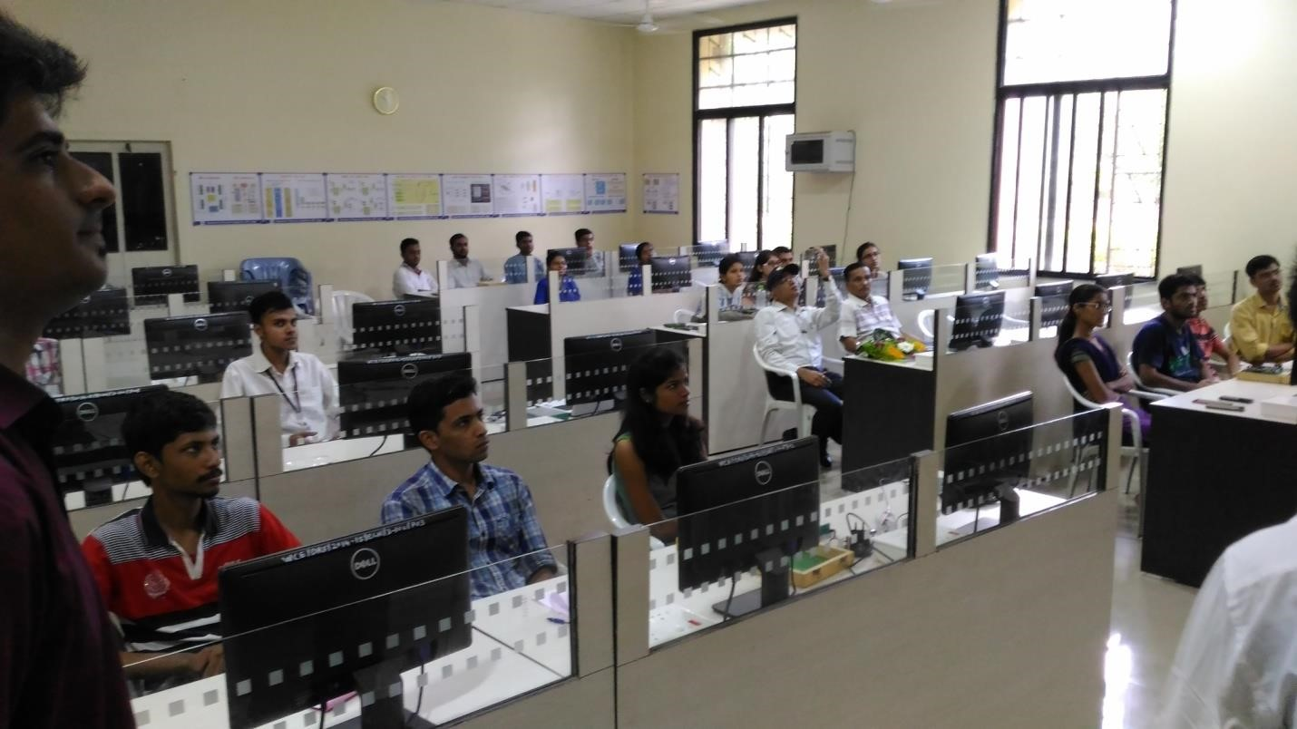

**Judge:** Mr.S. N. Kore

**Venue:** ESM lab of Electronics Department

**Winner:** Mr. Aditya Deodhar, Mr. Prathamesh Kale, Hrushikesh Budhale and Satyajeet Patil

**Consolation Price:** Swapnil Mane and Pravin Patil, Mr. Vijay Gole and Mr. Vikas Ghubade

|  |  |
| --- | --- |
| **Board** | **Name** |
| B Tech | 1.Narsing Mundhe  2. Tejshree Chaugule |
| TY Board | 1. Mayoddin Nathani 2. Abhishek Patil 3. Shubham Mhatre 4. Harish Agarwal |

# Quizonic

….. A platform to reveal your wisdom

This event was organized on the second day of the mega event. Where we had huge response of **238** entries. It was a competition to test your general knowledge and quiz solving ability in constrain of time. The response and feedback for this event was very sound. Participants were satisfied by good quality questions and puzzles. Entry fee was **50 Rs**. per team. Maximum **2 members per team** were allowed.

The structure of the event was as follows:-

**Round 1: Aptitude test** (10:00-10:30am and 10:30-11:00am)

This test was consisting of 40 questions based on general knowledge. The questions were based on current affairs, history, science etc.

## Round 2: Domain selected questions (12:30pm to 02:00pm)

In this round, Team has to solve a puzzle and it will lead to selection of one domain based on which the GK questions were asked. The domains were as follows: science, economics, sports, politics, current affairs, history, and inventions.

**Round 3:-** (03:00pm to 05:00pm)

In this round there were total 8 questions to be answered. The quality of questions was really good as participants said. The questions included one audio, one image and one question on each domain. The final score of the contenders lead to winning.

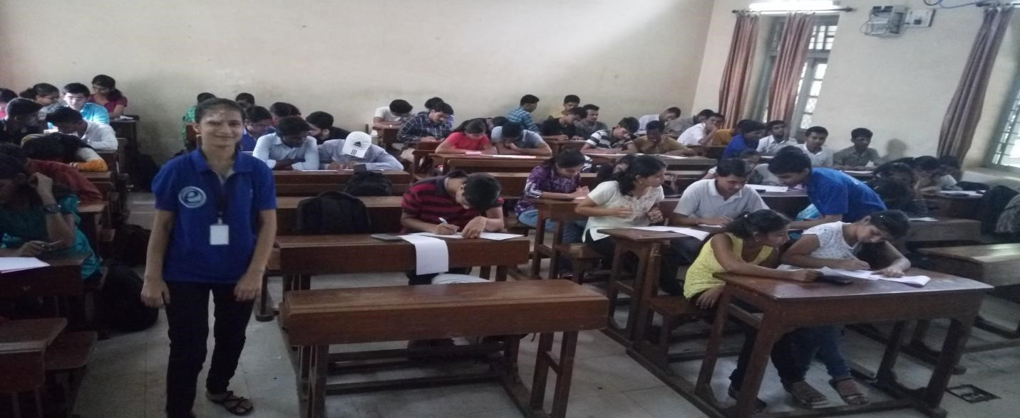

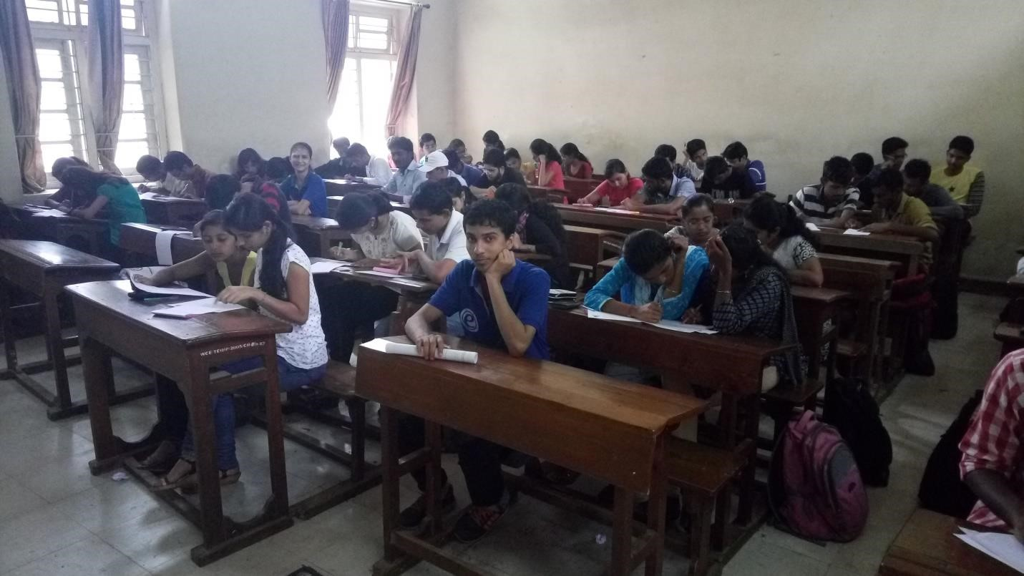

**Venue:** Classroom no. 3, 8, 9 and 10.

**Winner:** Miss Pooja Hasure and Miss Sushma Bhilawade.

**Runner up:** Mr. Aniket Kagne and Mr. Abhishek Patil.

## Organizing committee:-

|  |  |
| --- | --- |
| **Board** | **Name** |
| B Tech | 1.Amol Gaykhe |
| TY Board | 1. Priyanka Patil 2. Madhavi Gulavani 3. Sumit Satpute |
| SY Board | 1. Pritesh Pawar 2. Ritu Patil 3. Atul Zine 4. Sharvari Kshirsagar |

# Auxesis

…….The platform to showcase your talent

This event was organized exclusively for First Year Engineering Students on the second day of the event. The prime purpose behind organizing this event was to provide first year students with a platform where they can show their skills and affirm their knowledge, command over language and versatility. Efforts were made to make this event informative and interactive. Total **89 entry** count was there for this event.

The structure of the event was as follows

**Round 1:- Aptitude Test** (10:00 am to 10:30 am)

This round was to check the metal ability of the competitors. The questions were based on quizzes, puzzles and some brain storming tricky questions. It was consisting of 40 questions.

## Round 2:- Presentation skills (12:00am to 2:00 am)

Among the competitors in the first round 30 were shortlisted for the second round. Dividing them in the team of 5 members, we have given a topic and asked to collect the views of the people about the topic. On the spot they were asked to do one among the follows: debate, speech, group discussion.

The judges for the this round were Mr. Hitesh Chaudhary (Former President of ELESA) and Mr. Yash Mali (Ex-ELESAite). After the round judges guided the participants about the presentation skills and the response of participants was very good.

## Round 3:- Bidding Event (03:00am to 05:00am)

Total 8 members were shortlisted for this round. There were some cyphers given to them and they were asked to solve it. To solve the cypher the key was needed which they have to earn from bidding with the given amount. Winners were selected depending on the score of the third round.

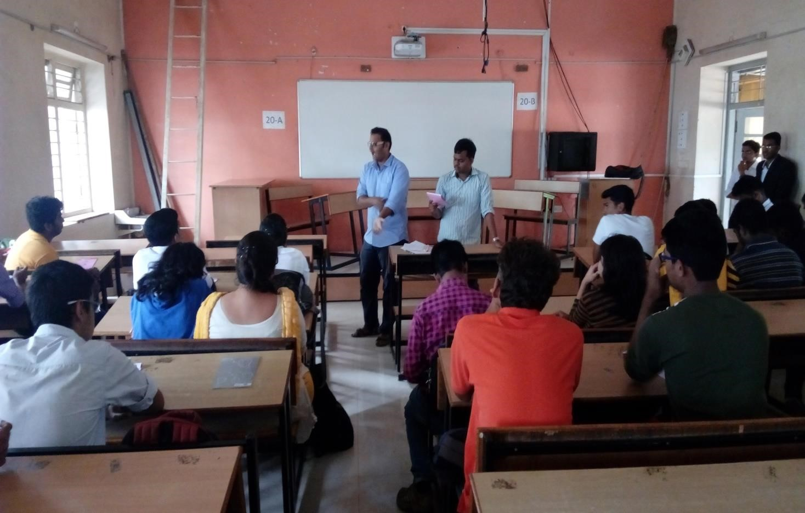

**Venue:** Classroom no. 19 and 20.

**Winner:** Mr. Sandeep Patil.

**Runner up:** Miss Aishwarya Thorat.

## Organizing committee:-

|  |  |
| --- | --- |
| **Board** | **Name** |
| B Tech | 1.Rukaiyya Shaikh |
| TY Board | 1. Amit Patil 2. Swarupa Ingale 3. Swaroop Tingare |
| SY Board | 1. Amol Shelke 2. Sumit Shinde 3. Shrihari Waskar |

# Reflux

…....Make a change with what you think

The event was a platform to present the innovative ideas which come to our mind and are helpful in various fields. It was organized on the second day of the event. The purpose of this round was to check the quality of the idea and presentation skill of the performer. There were **123 entries** for the event; the entry fee was **80 Rs**. Per team. A team could have maximum two participants.

There were 5 topics for the paper presentation.

1. Robotics for Human Comfort.
2. Radar- mean for a navigation.
3. Digital India.
4. Automation Industries.
5. Wireless Communication.

Structure of the event:-

The participants were asked to submit the abstract of the paper on electrovert2016@gmail.com. It was the whole day event. The participants had to give a **presentation on selected topic for 10 min**. With the help of video- audio picture presentation, participants presented the paper. The judges were assigning marks for them by various aspects of the presentation. The selection of the winner took place by the total score obtained.

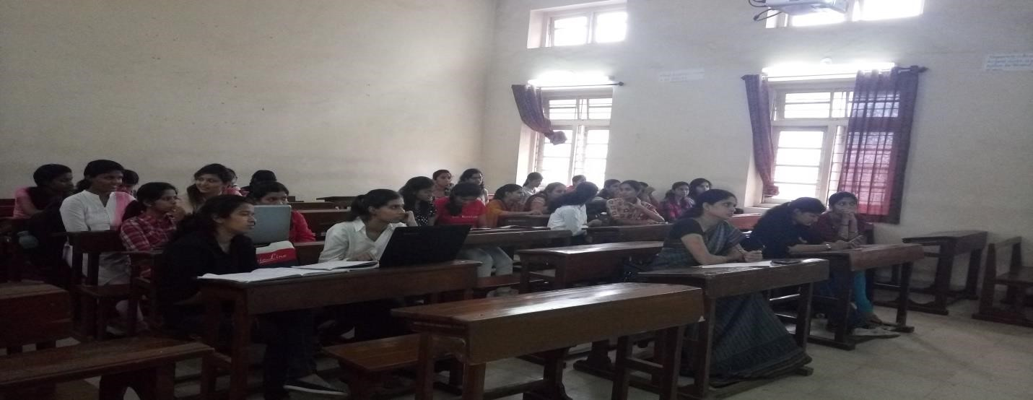

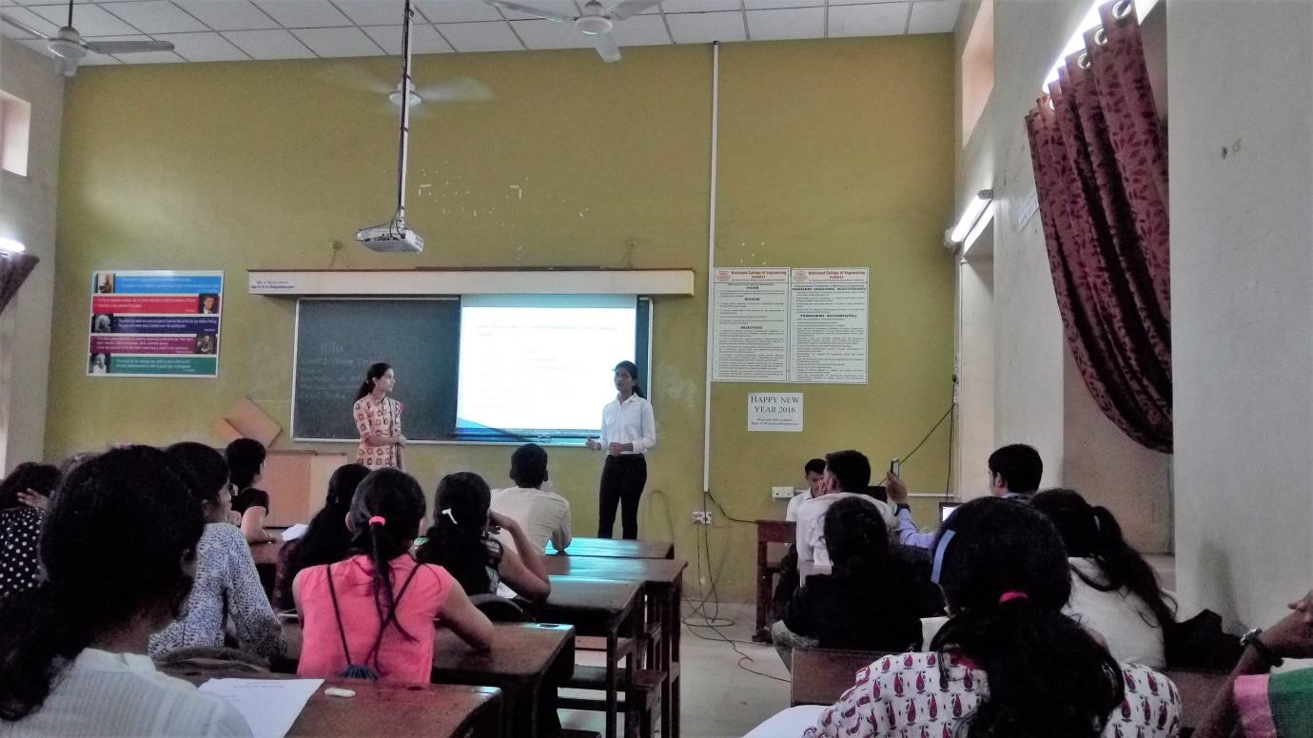

**Venue:** Classroom no. 1, 2, 11, 12 and 13.

**Judges**:- Mr. Sander Ghuge, Mr. Ashish Chavan, Miss Vaibhavi Rokade, Mr. Kiran

Shinde, Mr. Sandeep Gore, Miss Snehlata Gore, Mr. Subhag Kambale, Mr. Abhijit

Shinde, Miss Heena Shaikh

**Winner:** Mr. Nagnath Masali and Mr. Priyam Goswami.

**Runner up:** Mr. Ashish Chikate and Mr. Sameer Bolshette.

## Organizing committee:-

|  |  |
| --- | --- |
| **Board** | **Name** |
| B Tech | 1. Amol Gaykhe |
| TY Board | 2.Shantanu Vipradas  3.Aditya Halkarnikar |
| SY Board | 1. Anuj Badave 2. Tejshree Ghogale |

# Procurro

……..Innovation made real

The event was all about the project presentation. As mini project and mega project became the main part of every academic year. We organized a competition based on a project presentation. The main motto behind this event to encourage the students to enhance their creativity in project building and they should be able to overcome the various problem faced by industries. There were **13 entries** for this event. The entry fee was **200 Rs**. Per team. The maximum participants in the team allowed were **4**. It was on the second day of the event.

Structure of the event:

The participants were asked to bring their pre-created projects. There was viva based on the project created by the participants. The judges were testing all the aspects of the project to use them practically also the presentation skills of the participants. After the assessment of all the contenders judges selected the winners.

The judges also gave advices for the participants for the betterment of the project.

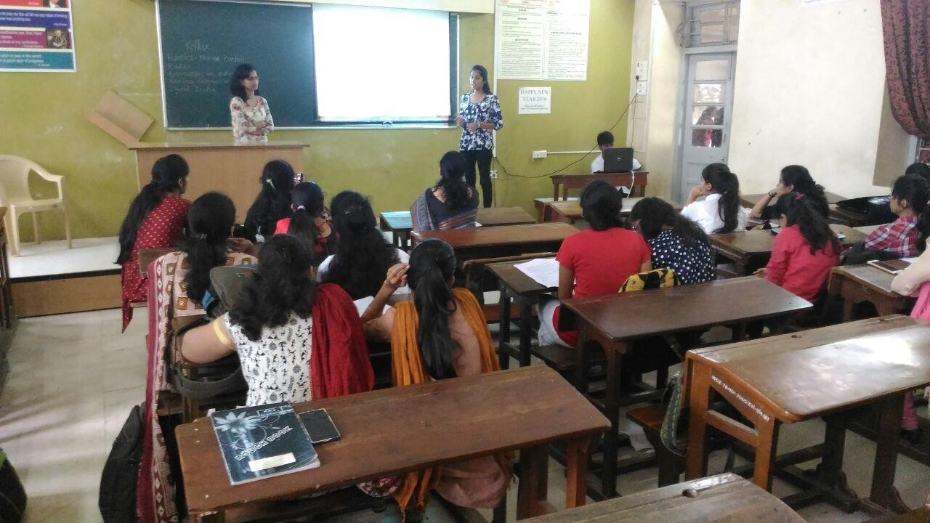

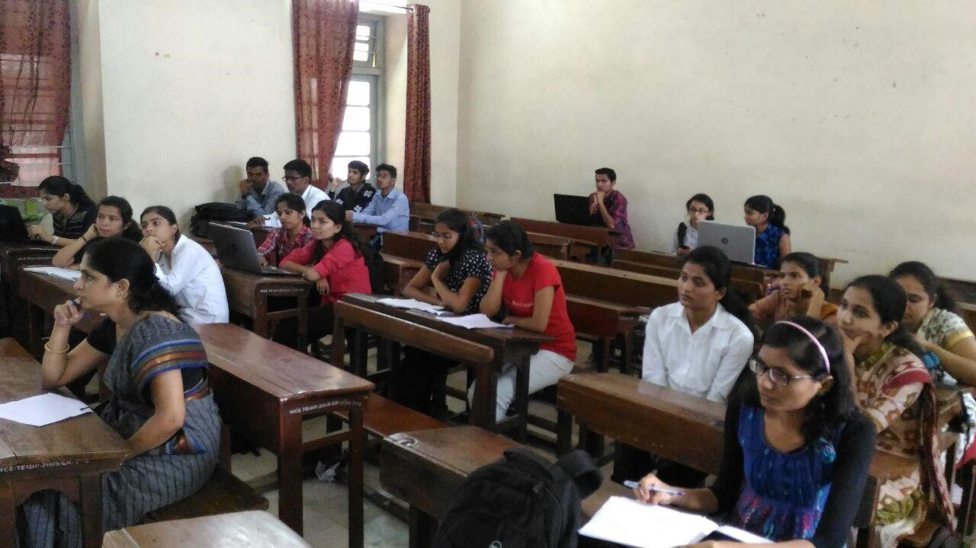

**Venue:** Communication Lab

**Judges:** Miss. S. U. Patil

**Winner:** Mr. Pratik Khndre, Miss Shreya Walvekar, Miss Gauri Patil, Mr. Rajesh Patil

## Organizing committee:-

|  |  |
| --- | --- |
| **Board** | **Name** |
| B Tech | 1.Sarswati Solage |
| TY Board | 1. Sunita Patil 2. Hrishikesh Nikam |
| SY Board | 1. Suraj Anarase 2. Komal Chandak |

# Organizing Board

|  |  |  |
| --- | --- | --- |
| **Board** | **Name** | **Post** |
| B Tech | Amol Gaykhe | President |
| Pawan Chopaded | Vice president |
| Rukaiyya Shekh | Event Director |
| Tejshree Chougule | Club service director and Aptitude developer |
| Sarswati Solage |
| Vidya Mane | Technical Director |
| Narsing Mundhe | Web Developer |
| Samruddhi Kulkarni | Treasurer |
| TY | Mayoddin Nathani | Secretary |
| Revati Shiudkar | Joint Event Director |
| Amit Patil | Joint Event Director |
| Swaroop Tingare | Joint Event Director |
| Pushkar Shirur | Joint Event Director |
| Shubham Mhatre | Joint Club Service Director |
| Pooja Aarekar | Joint Club Service Director |
| Swarupa Ingle | Joint Club Service Director |
| Aditya Halkarnikar | Joint Club Service Director |
| Akash Mundhe | Joint Technical Director |
| Abhishek Parab | Joint Technical Director |
| Sunita Patil | Joint Technical Director |
| Shantanu Vipradas | Joint Aptitude Developer |
| Omkar Shingare | Joint Aptitude Developer |
| Priyanka Patil | Joint Aptitude Developer |
| Saurabh Kale | Joint Web Developer |
| Harish Agarwal | Joint Web Developer |
| Saish Gosavi | Joint Editor |
| Pratik Thepale | Joint Editor |
| Hrishikesh Nikam | Joint Treasurer |
| Madhavi Gulavani | Joint Treasurer |
| Sumit Satpute | Service Organiser |
| Raunak Suryavanshi | Service Organiser |
|  | Shrihari Waskar | Joint Secretary |
| SY | Pritesh Pawar | Assistant Event Director |
| Ritu Patil | Assistant Event Director |
| Sharvari Kshirsagar | Assistant Event Director |
| Atul Zine | Assistant Club Service Director |
| Komal Chandak | Assistant Club Service Director |
| Sumit Shinde | Assistant Club Service Director |
| Tejshree Ghogale | Assistant Club Service Director |
| Swapnil Deshmukh | Assistant Technical Director |
| Sachin Jadhav | Assistant Technical Director |
| Shirish Patil | Assistant Technical Director |
| Amol Shelke | Assistant Aptitude Developer |
| Anuj Badave | Assistant Aptitude Developer |
| Mahadev Mishal | Assistant Aptitude Developer |
| Suraj Anarase | Assistant Web Developer |
| Snehal Patil | Assistant Web Developer |
| Balaji Koshti | Assistant Editor |
| Harshad Ugale | Assistant Editor |
| Vrushali Shelar | Assistant Treasurer |
| Supriya Sawant | Assistant Treasurer |
| FY | Niharika Bhoi | FE Co-ordinator |
| Alhad Manure | FE Co-ordinator |
| Sandeep Patel | FE Co-ordinator |
| Ajit Attarde | FE Co-ordinator |
| Tanvi Magdum | FE Co-ordinator |
| Amey Surve | FE Co-ordinator |
| Vaibhav Patil | FE Co-ordinator |
| Shubhankar Patil | FE Co-ordinator |